Program Information | [Lesson Title]  Buying for Irregularities |  |  |  |  | TEACHER NAME |  |  |  | PROGRAM NAME
Program Information | [Unit Title] |  |  |  |  | NRS EFL(s)  3 – 5 |  |  |  | TIME FRAME  120 minutes
Instruction | ABE/ASE Standards – Mathematics
Instruction | Numbers (N) |  |  | Algebra (A) |  | Geometry (G) |  |  | Data (D)
Instruction | Numbers and Operation |  |  | Operations and Algebraic Thinking | A.3.7 | Geometric Shapes and Figures |  | G.3.5, G.4.2, G.4.3, G.4.4 | Measurement and Data
Instruction | The Number System |  |  | Expressions and Equations |  | Congruence |  |  | Statistics and Probability
Instruction | Ratios and Proportional Relationships |  |  | Functions |  | Similarity, Right Triangles. And Trigonometry |  | G.4.8 | Benchmarks identified in RED are priority benchmarks. To view a complete list of priority benchmarks and related Ohio Aspire lesson plans, please see the Curriculum Alignments located on the Teacher Resource Center (TRC).
Instruction | Number and Quantity |  | N.5.1 |  |  | Geometric Measurement and Dimensions |  | G.5.2
Instruction |  |  |  |  |  | Modeling with Geometry
Instruction | Mathematical Practices (MP)
Instruction | ☑ | Make sense of problems and persevere in solving them. (MP.1) |  |  |  | ☑ | Use appropriate tools strategically. (MP51)
Instruction | ☑ | Reason abstractly and quantitatively. (MP.2) |  |  |  | □ | Attend to precision. (MP.6)
Instruction | □ | Construct viable arguments and critique the reasoning of others. (MP.3) |  |  |  | ☑ | Look for and make use of structure. (MP.7)
Instruction | ☑ | Model with mathematics. (MP.4) |  |  |  | □ | Look for and express regularity in repeated reasoning. (MP.8)
Instruction | LEARNER OUTCOME(S)  - Students will choose proper units and tools for measurements.  - Students will be able to use established formulas to calculate perimeter (circumference), area, and volume for both basic and irregular figures. |  |  |  |  | ASSESSMENT TOOLS/METHODS  - Each of the “You do” steps will serve as assessment. The instructor should be able to gauge understanding by having different students provide their solutions and explanations of how they arrived at that solution. In addition, during the “we do” steps, instructors should be encouraging all students to participate in the discussion. The ability to provide input in these discussions will help the teacher gauge each student’s mastery of the concepts.  - You can have students turn in any 4th problems on the House Designs handout and/or the Yard Dimensions handout.
Instruction | LEARNER PRIOR KNOWLEDGE  - Vocabulary about properties and attributes of 2-D and 3-D figures  - Ability to work with arithmetic of whole numbers and decimals (for pi), as well as knowledge of raising to the powers of 2 and 3.
Instruction | INSTRUCTIONAL ACTIVITIES  Note: Keep in mind that your class may not need to go through each of the parts below. Please pick and choose which elements to incorporate into your actual lesson based on what you know of your students. In addition, extra sample problems may need to be incorporated based upon your particular class  - The first part of this lesson is going to deal with measuring and converting. Have multiple things available for students to measure with different tools. You will want to have things of varying size so that students can use the different measuring tools. Just using things in the classroom, students could measure their desks, the distance across the room, or their hands. To get a mile measurement, you could ask them the distance from your site to their home. Depending on class size, you could break them up into pairs or small groups to measure each item.  Have students share their measurements and note them on the board. Students may have used different units for measuring the same object. For example, if they measured their hands, some may have used inches and others centimeters. Or, for the room, some may have used feet and other inches. This could open up a time for discussion about units of measurement and when to use one over another. Smaller units will give us more precision, but also require larger numbers. Larger units give us more manageable numbers but may require us to round or use fractional units. However, using different units is fine, because we can always convert them to our desired units. Using Measuring with Maggie: An Introduction to US Standard Units, we will now explore converting units. There are two types of conversions: those within the same system and those between the two systems (US and metric). We will do one of each type and use explicit instruction to model it.  (I do) Whether converting within or between unit systems, the idea is the same. We want to multiply by fractions, known as conversion factors, until we get to our desired units. Let’s start by converting within the US system and use length measurements. For instance, if we want to find out how many inches are in 3 yards, we will first look at the Metric – US/Imperial Conversion Charts and see:  The yellow highlighted row is the one we want to look at. It tells us that one yard contains three feet. So we can convert our 3 yards into feet: 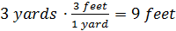. Make sure to note where units cancel out. You can explain that it works just like cancelling out factors as if you were multiplying fractions: 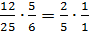. From there, we want to look at the green highlighted row since we are aiming for inches. This tells us 1 foot contains 12 inches. We have 9 feet, so we have: 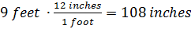.  (We do) Now, the class will work with you and guide you through the conversion process. We want to find the number of inches in a mile. We will use this chart again:  We must this time start with the blue line and this equation:  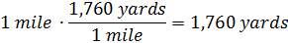  Next, we move to the yellow line, and this equation:  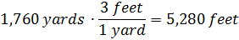  Finally, we move to the green line, and this equation:  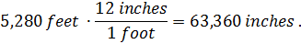  (You do) Now have the students work on their own (or in pairs) to convert some of the measurements they found during the exploration process. Afterwards, come back together as a class to see if their findings were similar.  - Measurements for perimeters, areas, and volumes are important when it comes to working around the home. When buying supplies for home projects, these measurements are often needed so that there is enough material and at the same time, to be cost efficient, not too much material. As such, let’s go over examples, and contexts, for these measurements.  (I do) For the beginning, students will need the SmartPals, a calculator (optional), and the House Designs handout. Starting with the perimeter section, we will go through and do the first problem from each section for the “I do” portion, and the second problem for the “We do” portion. Any remaining problems will be for student completion. First, students will need to know what perimeter is. Give them a basic definition. This could be discussion based. Students may already have an idea about perimeter being the distance around an object. While formulas exist for shapes, they are rather unnecessary for this particular concept and are probably more difficult than just remembering to sum all the side lengths. This would be a personal preference, though, and can be done as instructors choose.  Our first problem in the perimeter section tells us we will be building a fence around a dog house. The house is 6 feet by 8 feet and the fence will extend out an additional 8 feet from each side of the dog house. In order to add the sides, we must first find them. Let’s draw a picture to help visualize our scenario.  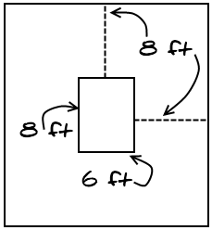  This tells us that the width of the enclosed space is 6 ft. plus 8 ft. on each side, so 6 + 8 + 8 = 22 ft. The length becomes 8 ft. plus 8 ft. on each side, or 8 + 8 + 8 = 24 ft. Then, since we have 2 widths and 2 lengths we have 22 + 22 + 24 + 24 = 92 feet of fencing needed. If we wanted to use the “formula” for the perimeter of a rectangle, we would take: , which checks our work. 92 feet of fencing is necessary.  (We do) Have the class walk you through solving the second problem. We have a circle, so we do have a formula this time around as circles are the oddballs when it comes to formulas. We have to do something to get pi in there. The formula is C. For this example, that becomes: C feet. (Note: While multiplying by 3.14 does give a concrete number that is probably easier for students to grasp and visualize, they should be familiar with leaving answers in terms of pi. Many tests will often ask for answers to be exact, or in terms of pi.)  (You do) Have the students work on at least the 3rd problem alone. They could turn in the 4th problem as an assessment piece, or you can use it as further in-class practice.  - (I do) We are now moving on to the area section. Here, formulas will become more important. But there are still just a few that we need to use. For instance, all triangles use the same formula, . In addition, since squares are a special case of rectangles, we can use for those as well. And finally, for circles, we will use .  Our first problem deals with finding the area of a rectangular space. We know the length and width are 8 ft. and 6 ft. Since we are working with a rectangle, we will be using the formula . For our problem, will become . Since we have a contextual problem, we need to go back and add in units. When we have area, we are multiplying two dimensions, so our answer should be in square units. Thus, Buster would have 48 ft² of space.  (We do) The second problem asks us about the area of the pool. While we do have a 3-d object and it does have a volume, we are looking for area as we want to know how many people can be contained within the circular barrier of the pool. We don’t want to see just how many people we can stuff above/below the water line in the actual pool, but just who can fit if everyone was standing up. Have the class walk you through setting up the correct formula and finding an answer: ft².  (You do) Have students do the final problems on their own, with the option of using the final one as a homework assessment. (Note: Make sure students know that the height of the triangle must make a right angle with the base!)  - We are now moving on to irregular measurements. Here, this just means that our shapes are no longer the simple, basic figures we are used to. Instead, they are combinations of those basic shapes. Our goal here, then, is to break the shapes up into pieces that we know. For perimeter, this just means breaking it up so that we can find any unknown sides and then adding up all the outside edges.  (I do) We want to find the perimeter of the desk shown. We are given many dimensions already, but not quite all of them. We do, know, however, that since we are working with perimeter, we just need to add up all the exterior lengths of the desktop. Since we have an irregular shape, there really is no formula to use as a shortcut. Instead, we must first find any missing lengths and then just use addition to find the sum. We need to find that missing length. Since the back portion of that piece is 72 inches, and the left portion of the L cuts across 24 inches, then the remaining length is 72 – 24 = 48 inches. Now, we just add up all of our lengths: 84 + 72 + 36 + 48 + 48 + 24 = 312 inches.  (We do) Here, have students walk you through how to find the solution. We need to find the perimeter denoted by solid lines in this image:  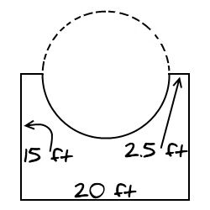  The missing portion is that half circle that is shown by a solid line. We can use the circumference formula and then take half, but we found the circumference of the pool in the first problem. Thus, we just need to take half of that amount (47.1) to get 23.55. We then want to add that to all the sides, remembering to include 2.5 and 15 twice each. We then have 23.55 + 2.5 + 2.5 + 15 + 15 + 20 = 78.55 feet.  (You do) Have the students do the final problem on the handout. It should be noted that the dotted, vertical line cuts the bottom edge in half. Also, drawing in the dotted green line below  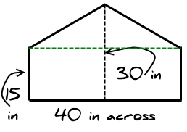  should help students see that there are two right triangles created at the top. We can then use the Pythagorean Theorem to find that the slanted sides of the top triangle are both 25 inches.  - When finding the area of irregular shapes, the need to break the overall shape down into more basic ones is even more important. For area, we use formulas to find the area of rectangles, triangles, and circles. Thus, we will need to break up more difficult figures into these basic shapes. Then, we will need to add or subtract to find the desired area.  (I do) For this first problem, we are asked to find the area between the fencing and the dog house. In other words, the shaded area:  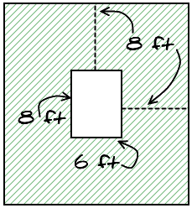  To do this, we will take the area of the entire fenced in space, and subtract the area of the doghouse. Since we found the width and length of the fenced in space to be 22 and 24 earlier, we know the area of that space is just their product, or 528 ft². If we take out the area of the doghouse which had been found earlier to be 48 ft² we end up with an area of 480 ft². There are other ways to go about this. We could divide the shaded area into smaller rectangles and find the area of each before taking their sums. No matter how we do it, we should arrive at the same answer.  (We do) Have the class walk you through doing the second problem. In this case, we are back to working with the pool and circles. We want to find the shaded area:  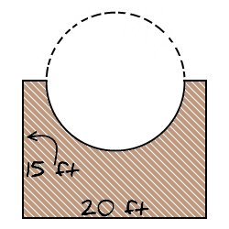  To do this, we will take the entire rectangle with dimensions 15x20 and take out the half circle that the pool occupies. Since we already know the area of the entire pool to be 176.6 ft², then we know the area of half of that would be 88.3 ft². We subtract that from the 300 ft² area of the rectangle to get 211.7 ft².  (You do) Have the students do the final problem on the handout. Once again, they’ll need to use the triangle at the top of the image to help them find the overall area. This time, it should be easier to add the rectangle at the bottom to the triangle at the top instead of subtracting anything.  Give them the Yard Dimensions handout to turn in for you to check their understanding.  Note: Due to time constraints, volume has been left out. However, if time permits, you can go over contextual examples of volume and irregular volume. After doing perimeter/area for basic and irregular shapes, volume follows the same idea. You want to break up the objects into known 3-dimensional figures. It should also be noted that volume formulas for most encountered shapes can be simplified into two formulas:  Prisms (including cubes) and Cylinders: , where B = the area of the base  Pyramids and Cones:  This may help students who have a hard time remembering multiple formulas. Sample problems can be found in the Volume of Composite shapes handout. |  |  |  |  | RESOURCES  Multiple things available for students to measure with different tools  Measuring tapes, rulers, yardsticks for student use  Chalk/white board  Computer with Internet access  Projector, ability to project  Measuring With Maggie: An Introduction to US Standard Units. (n.d.). Retrieved from http://www.mathsisfun.com/measure/us-standard-units-introduction.html  Metric - US/Imperial Conversion Charts. (n.d.). Retrieved from http://www.mathsisfun.com/metric-imperial-conversion-charts.html  SmartPal kits for student use  - Inserting a blank sheet of paper into the sleeves will give students a reusable sheet of paper that they can quickly try answers out on and erase without using up a pencil eraser. It’s quicker as well. For this lesson, we will want the grid handout provided inserted.  Calculators for student use  Student copies of House Designs Handout (attached)  Student copies of Yard Dimensions Handout (attached)  Student copes of Volume of Composite Shapes Handout (attached)
  US or Imperial |  |  | Metric
  1 inch [in] |  |  | 2.54 cm
  1 foot [ft] | 12 in |  | 0.3048 m
  1 yard [yd] | 3 ft |  | 0.9144 m
  1 mile | 1760 yd |  | 1.6093 km
  1 int nautical mile | 2025.4 yd |  | 1.853 km
  US or Imperial |  |  | Metric
  1 inch [in] |  |  | 2.54 cm
  1 foot [ft] | 12 in |  | 0.3048 m
  1 yard [yd] | 3 ft |  | 0.9144 m
  1 mile | 1760 yd |  | 1.6093 km
  1 int nautical mile | 2025.4 yd |  | 1.853 km
 | DIFFERENTIATION
Reflection | TEACHER REFLECTION/LESSON EVALUATION
Reflection | Additional Information  Next Steps  After this lesson, a follow-up may be to plot shapes or partial shapes onto coordinate grids to reinforce their properties or to see if students can complete the pictures. Another possibility is to go further into formulas of more complicated shapes, especially that of surface area.  Purposeful/Transparent  Since students want to be able to apply perimeter, area, and volume to contextual situations, instructors will cover these topics theoretically, but also with applied examples from around the home.  Contextual  Many topics in geometry give way to application problems with ease and this topic is no different. All shapes found in the real world have perimeter, area, and/or volume depending on their dimensions. These topics are useful to everyone as well. In a house, do you have enough room for your furniture? Is there enough space in your bedroom for your bed, desk, and dresser? Is there enough volume space in your car for all the things you need to haul? How much fencing is needed to enclose the backyard?  Building Expertise  Perimeter, area, and volume can be introduced with or without equations/formulas. If they are introduced before students are completely comfortable with equations, they may help reinforce how to solve equations and how to find answers using formulas. This topic gives a concrete and visual representation to some often used formulas.
House Designs
Perimeter
1.  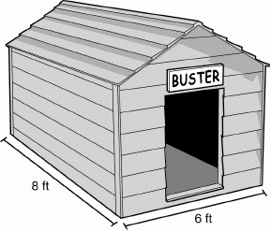  There are plans to build a doghouse with the dimensions above. If we wanted to fence in a space that is an additional 8 feet from each side of the doghouse, what amount of fencing would we need to do so? | 2.  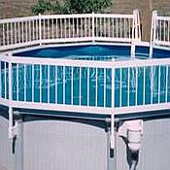  The family decides to put a pool up in the backyard. Since they have children, they want to check the price of some safety fencing that could go up around the outside of the pool as seen above. If the pool is 15 feet across and the fencing is sold by length, how much fencing should be purchased?
3.  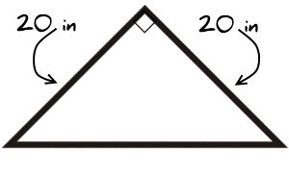  This new house they are designing has a half bathroom on the first floor that is rather small. To save space, they decide to put the counter on the sink in the corner. For a modern design, they go with the triangular shape shown above. Find the length of the front of the sink as well as the total perimeter of the counter. | 4.  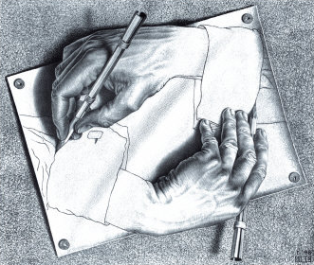  The owners want to put the above painting by Escher in a frame. It measures 26 inches in width by 22 inches in height. If wood is bought by total length, how much should be purchased?

Area
1.  If the above doghouse is built for Buster, how much area will he have to move about inside the house? | 2.  Once again, the family wants to put in the above ground pool seen above. They want it to be 15 feet across. What will be the area that people can swim in?
3.  After installing the new counter in the half bathroom, how much area is being used up based on the dimensions above? | 4.  After buying materials to frame above picture from our previous problem, the frame extended the picture by 2 inches on all sides. How much space on the wall will the framed picture take up?

Irregular Perimeter
1.  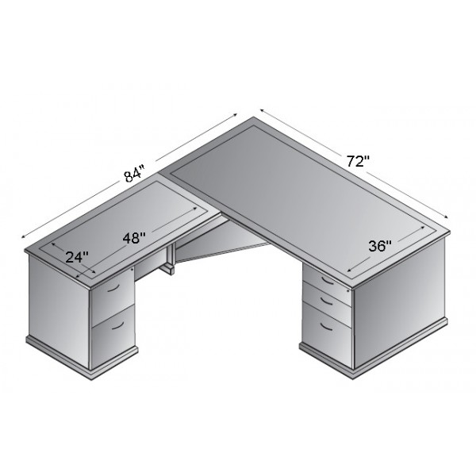  In the office, the owners want to put the desk shown above. Given those dimensions, find the distance around the entire outside of the desk. | 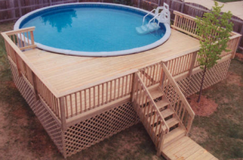  2.  Deciding they’d rather have a deck surrounding part of the pool than the safety fence going all the way around, the above design is decided upon. The deck will start at the widest portion of the pool. Without the cutout portion where the pool is, the dimensions of the deck are 20 feet by 15 feet. The fencing along the bottom, below the deck portion, surrounds the entire deck (including the portion between the pool wall and the actual deck). What length of fencing would be necessary to complete that bottom portion?
3.
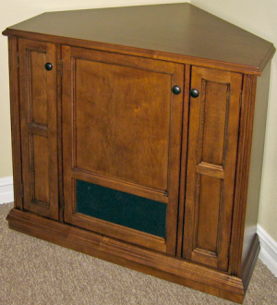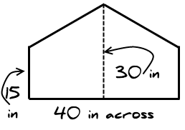

The TV stand above is designed to go in the corner of a room. The shape on top is similar to that of a home plate in baseball. If you know the given dimensions, what is the perimeter of the TV stand top?
Irregular Area
1.  Going back to the fenced in area we created in the first part of this activity, how much area will Buster have to play in between the fence and his house? | 2.  We are once again working with the deck pictured above. The deck will start at the widest portion of the pool. Without the cutout portion where the pool is, the dimensions of the deck are 20 feet by 15 feet. What is the area of the portion of the deck that can be walked on?
3.

Once again, we are working with the TV stand and the dimensions above. This time, what is the area of the TV stand top?
House Designs
Perimeter
1.  There are plans to build a doghouse with the dimensions above. If we wanted to fence in a space that is an additional 8 feet from each side of the doghouse, what amount of fencing would we need to do so?  92 feet of fencing is needed | 2.  The family decides to put a pool up in the backyard. Since they have children, they want to check the price of some safety fencing that could go up around the outside of the pool as seen above. If the pool is 15 feet across and the fencing is sold by length, how much fencing should be purchased?  About 47.1 feet of fencing is needed
3.  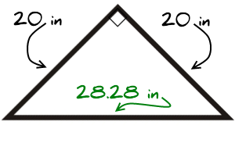  This new house they are designing has a half bathroom on the first floor that is rather small. To save space, they decide to put the counter on the sink in the corner. For a modern design, they go with the triangular shape shown above. Find the length of the front of the sink as well as the total perimeter of the counter.  The perimeter of the piece is 68.28 inches | 4.  The owners want to put the above painting by Escher in a frame. It measures 26 inches in width by 22 inches in height. If wood is bought by total length, how much should be purchased? 96 inches of frame is needed
Area
1.  If the above doghouse is built for Buster, how much area will he have to move about inside the house?  48 ft² | 2.  Once again, the family wants to put in the above ground pool seen above. They want it to be 15 feet across. What will be the area that people can swim in?  176.6 ft²
3.  After installing the new counter in the half bathroom, how much area is being used up based on the dimensions above?  200 in² | 4.  After buying materials to frame above picture from our previous problem, the frame extended the picture by 2 inches on all sides. How much space on the wall will the framed picture take up?  624 in²
Irregular Perimeter
1.  In the office, the owners want to put the desk shown above. Given those dimensions, find the distance around the entire outside of the desk.  312 inches | 2.  Deciding they’d rather have a deck surrounding part of the pool than the safety fence going all the way around, the above design is decided upon. The deck will start at the widest portion of the pool, with 2.5 feet of extra space to either side. Without the cutout portion where the pool is, the dimensions of the deck are 20 feet by 15 feet. The fencing along the bottom, below the deck portion, surrounds the entire deck (including the portion between the pool wall and the actual deck). What length of fencing would be necessary to complete that bottom portion? 78.55 feet
3.

The TV stand above is designed to go in the corner of a room. The shape on top is similar to that of a home plate in baseball. If you know the given dimensions, what is the perimeter of the TV stand top? 120 inches

Irregular Area
1.  Going back to the fenced in area we created in the first part of this activity, how much area will Buster have to play in between the fence and his house?  480 ft² | 2.  We are once again working with the deck pictured above. The deck will start at the widest portion of the pool. Without the cutout portion where the pool is, the dimensions of the deck are 20 feet by 15 feet. What is the area of the portion of the deck that can be walked on?  211.7 ft²
3.

Once again, we are working with the TV stand and the dimensions above. This time, what is the area of the TV stand top? 900 in²
Volume of Composite Shapes

- If some homeowners decide to build a garage with the dimensions below, how much space will they have inside the structure?
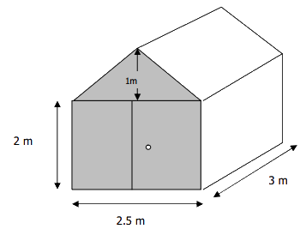
- If a new factory is built with the dimensions as given in the image below, what would be the overall volume of the new building?
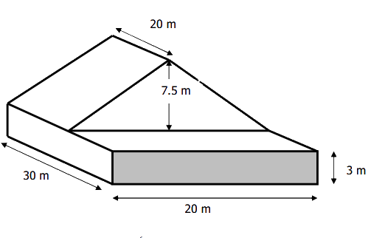
Volume of Composite Shapes
- If some homeowners decide to build a garage with the dimensions below, how much space will they have inside the structure?
18.75 m³
- If a new factory is built with the dimensions as given in the image below, what would be the overall volume of the new building?
3,300 m³
Yard Dimensions
The Matthews family was looking into buying a new house. With two children, they knew they would want a yard for them to play in. After looking at the house below, they realized they would need to build a fence in order to block the kids from the creek and the crop of trees. If they built the fence outlined below, how many feet of material would be needed and what be the area of the enclosed yard that the kids could play in? (Hint: The area the house itself takes up would not be included as yard since you cannot play on that patch of land.)
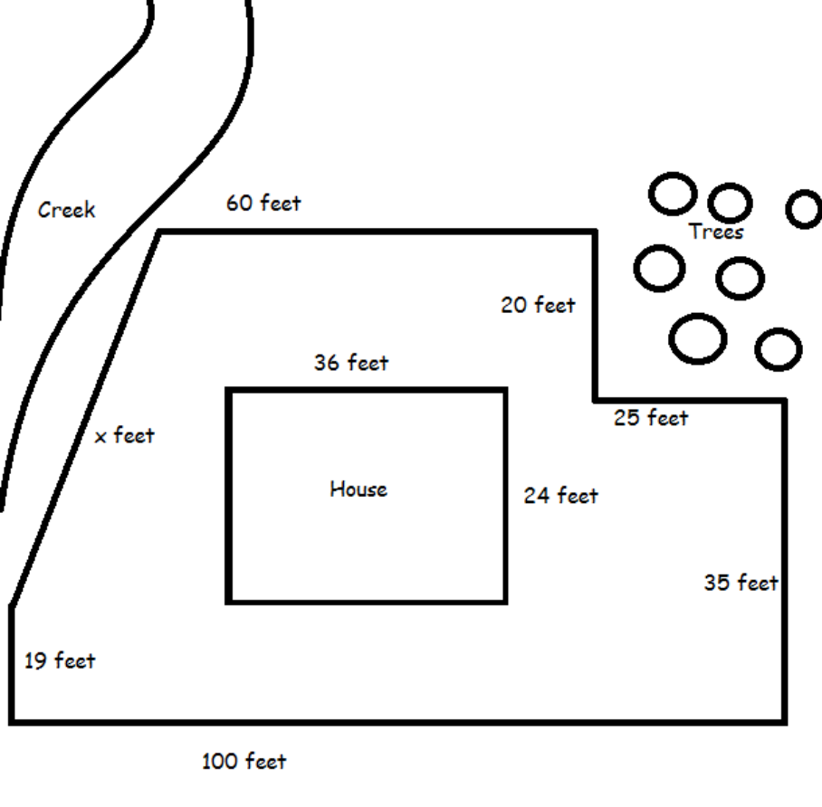
Yard Dimensions
The Matthews family was looking into buying a new house. With two children, they knew they would want a yard for them to play in. After looking at the house below, they realized they would need to build a fence in order to block the kids from the creek and the crop of trees. If they built the fence outlined below, how many feet of material would be needed and what be the area of the enclosed yard that the kids could play in? (Hint: The area the house itself takes up would not be included as yard since you cannot play on that patch of land.)


